**DAILY FRESH FRUITS** A Project Report Submitted To The Madurai Kamaraj University In Partial Fulfilment for the Award of the Degree

# BACHELOR OF COMPUTER APPLICATIONS

(2020 - 2023)

*Submitted by*

**R.BABIN PRATHEEVE**

**20BCA112**

*Under the Guidance of*

# Mrs.S.SARMILA MCA, M.E(CSE)

# ASSISTANT PROFESSOR



**THE AMERICAN COLLEGE**

An Autonomous Institution affiliated to Madurai Kamaraj University

( Re-accredited (3rd cycle) by NAAC with Grade “A+” CGPA-3.47 on a 4-points scale ) Madurai – 625002.



**THE AMERICAN COLLEGE DEPARTMENT OF**

**COMPUTER APPLICATIONS** An Autonomous Institution affiliated to Madurai Kamaraj University

( Re-accredited (3rdcycle) by NAAC with Grade “A+” CGPA-3.47 on a 4-points scale ) Madurai – 625002.

**CERTIFICATE**

This is to certify that this Project titled **DAILY FRESH FRUITS** is a bonafide work done by **R.BABIN PRATHEEVE (20BCA112)** in Partial Fulfillment for the award of the degree of **Bachelor of Computer Applications** of **The American College, Madurai** for the Academic year 2020-2023.

**Mrs.S.SARMILA, MCA, M.E(CSE)**

**ASSISTANT PROFESSOR Mrs.T.SUGANYA,M.Sc.,M.Phil.,SLET,(Ph.D)**

**Internal Guide Head of the Department**

Submitted for the Viva-Voice examination held on

Internal Examiner External Examiner

## DECLARATION

I hereby declare that this project was carried out by me under the guidance of Mrs.S.SARMILA, MCA, M.E.(CSE) Department of Computer Applications, The American College, Madurai.

I also declare that this project report is the result of my own effort and that it has not been copied from any one and has not been submitted by anybody in anywhere.

**Place: Madurai R.BABIN PRATHEEVE**

**Date: (20BCA112)**

## ACKNOWLEDGEMENT

I am pleased to convey my sincere thanks to our Principal **Dr. M. Davamani Christober, M.Sc., M.Phil., M.Ed., PGDCA, Ph.D.(Inter Disciplinary), Ph.D.(Math).**

I am Grateful to Head of our department **Mrs.T.SUGANYA,M.Sc.,M.Phil.,SLET,(Ph.D)** for her Energetic Encouragement and support.

I express my deep sense of Gratitude and Indebtedness to **Mrs.S.SARMILA, MCA, M.E(CSE)** for inspiring guidance and continuous encouragement which has enabled me to complete this project.

Also I would like to thank my Teachers, Friends and my well wishers who have helped me during the course of completion of this project.

.

**CONTENT**

|  |  |  |
| --- | --- | --- |
| **S.NO** | **TITLE** | **PAGE NO** |
| **1** | **INTRODUCTION** |  |
|  | 1.1 ABSTRACT | 1 |
| **2** | **SYSTEM ANALYSIS** |  |
|  | 2.1 EXISTING SYSTEM | 2 |
|  | 2.2 PROPOSED SYSTEM | 2 |
|  | 2.3ADVANTAGES | 3 |
|  | 2.4 FEASIBLITY STUDY | 3 |
| **3** | **SYSTEM CONFIGURATION** |  |
|  | 3.1 HARDWARE REQUIREMENTS | 4 |
|  | 3.2 SOFTWARE REQUIREMENTS | 4 |
|  | 3.3 SOFTWARE DESCRIPTION | 5 |
| **4** | **PROJECT SPECIFICATION** |  |
|  | 4.1 MODULES SPECIFICATION | 12 |

|  |  |  |
| --- | --- | --- |
| **5** | **SYSTEM DESIGN** |  |
|  | 5.1 INPUT &OUTPUT DESIGN | 15 |
|  | 5.2 3 DATA FLOW DIAGRAM | 17 |
|  | 5.3 DATABASE DESIGN | 20 |
| **6** | **SYSTEM TESTING** |  |
|  | 6.1 UNIT TESTING | 23 |
|  | 6.2 INTEGRATION TESTING | 24 |
|  | 6.3 VALIDATION TESTING | 24 |
| **7** | **IMPLEMENTATION** | 25 |
| **8** | **CONCLUSION** | 26 |
|  | 8.1 FUTURE ENHANCEMENT | 26 |
| **9** | **REFERENCE** | 27 |
| **10** | **ANNEXURE** |  |
|  | 10.1.SCREENSHOT | 28 |
|  | 10.2.SAMPLE CODING | 36 |

# INTRODUCTION

## ABSTRACT :

―This project is developed for my own Fruit’s Export and Import company.‖

This project includes ―buying and ordering fruits through online‖. In this single website the user can buy their fruits on seeing the availability of what fruit they needed, user can easily select the variety of fruit based on the quality. And finally they can even calculate the total purchase of their products. Now a days we are need to be avoid crowding in public areas for our safety measures that’s the main purpose of this webpage, the user can simply ordered their fruits through online without the need to crowed .

In the Administrative login the admin could update the stocks. If the stocks become lesser than the limit, an alert message will show the fruit will not available for the next day selling,(the product need to be ordered now). Admin can only see the total selling of products on the day end and also admin can manage the staff details on their login. In the existing system there can only ordering and buying of products without seeing the product availability, and here I include the pre-booking system that contains

booking of a huge amount of fruits for their upcoming functions and household needs.

# SYSTEM ANALYSIS

## EXISTING SYSTEM:

In the existing system, the customers ordered their products without seeing the availability of the fruits. This will leads to disappointment for the customers about their orders.

In those existing system the customers place their orders by unknowingly the varieties of the fruits, what they needed to purchase. This frustrated the customer expectations about their varieties of the fruits. Because, nowadays people knows about the various fruits and their varieties available.

## PROPOSED SYSTEM:

In the proposed system, the customers can order their products by seeing the availability of the fruits. It makes the customers to fulfill their needs.

In this system I included the selection of varieties of the fruits for the customer needs. This makes the customers more comfortable and satisfies their needs of varieties what they want. I included the location with the directions and also i added the address of the shop for the customer verification.

I attached a pre-booking system, that allows you to place your orders for you expecting date for your future needs.

## ADVANTAGES:

* + - Time saving – This system saves your time of purchasing the fruits by sort out with the good quality.
    - Selection of varieties – The customer can select the varieties of fruits in our system that makes their expectation fulfilled.
    - Location guide – Our location guides you to our shop with the help of embedded Google map.

## FEASIBILITY STUDY:

Preliminary investigation examine project feasibility, the likelihood the system will be useful to the organization. The main objective of the feasibility study is to test the Technical, Operational and Economical feasibility for adding new modules and debugging old running system. All system is feasible if they are unlimited resources and infinite time. There are aspects in the feasibility study portion of the preliminary investigation:

* Technical Feasibility
* Operational Feasibility
* Economical Feasibility

# SYSTEM CONFIGURATION

## HARDWARE REQUIREMENTS:

Processor : AMD A4-9120e RADEON R3, 4 COMPUTE CORES 2C +2G 1.50 GHz RAM : 4 GB

Hard Disk Drive : 1 TB

Mother board : Intel core i5 mother board Mouse : Optical mouse

## SOFTWARE REQUIREMENTS:

Operating System : Windows 10 Front End : HTML CSS

Back End : PHP

Database : My SQL

## SOFTWARE DESCRIPTION:

* + 1. **HTML:**

HTML elements are the building blocks of HTML pages. With HTML constructs, images and other objects such as interactive forms may be embedded into the rendered page. HTML provides a means to create structured documents by denoting structural semantics for text such as headings, paragraphs, lists, links, quotes and other items. HTML elements are delineated by tags, written using angle brackets. Tags such as <img

/> and <input /> directly introduce content into the page. Other tags such as <p> surround and provide information about document text and may include other tags as sub- elements. Browsers do not display the HTML tags, but use them to interpret the content of the page.

HTML can embed programs written in a scripting language such as JavaScript, which affects the behavior and content of web pages. Inclusion of CSS defines the look and layout of content. The World Wide Web Consortium (W3C), former maintainer of the HTML and current maintainer of the CSS standards, has encouraged the use of CSS over explicit presentational HTML since 1999.

Berners-Lee considered HTML to be an application of SGML. It was formally defined as such by the Internet Engineering Task Force (IETF) with the mid-1993 publication of the first proposal for an HTML specification, the "Hypertext Markup Language (HTML)" Internet Draft by Berners-Lee and Dan Connolly, which included an SGML Document type definition to define the grammar. The draft expired after six months, but was notable for its acknowledgment of the NCSA Mosaic browser's custom tag for embedding in-line images, reflecting the IETF's philosophy of basing standards on successful prototypes. Similarly, Dave Raggett's competing Internet-Draft, "HTML+ (Hypertext Markup Format)", from late 1993, suggested standardizing already-implemented features like tables and fill-out forms.

## CSS:

Cascading Style Sheets (CSS) is a style sheet language used for describing the presentation of a document written in a markup language such as HTML. CSS is a cornerstone technology of the World Wide Web, alongside HTML and Java Script.

CSS is designed to enable the separation of presentation and content, including layout, colors, and fonts. This separation can improve content accessibility, provide more flexibility and control in the specification of presentation characteristics, enable multiple web pages to share formatting by specifying the relevant CSS in a separate .css file which reduces complexity and repetition in the structural content as well as enabling the .css file to be cached to improve the page load speed between the pages that share the file and its formatting.

Separation of formatting and content also makes it feasible to present the same markup page in different styles for different rendering methods, such as on-screen, in print, by voice (via speech-based browser or screen reader), and on Braille-based tactile devices. CSS also has rules for alternate formatting if the content is accessed on a mobile device.

The name cascading comes from the specified priority scheme to determine which style rule applies if more than one rule matches a particular element. This cascading priority scheme is predictable.

The CSS specifications are maintained by the World Wide Web Consortium (W3C). Internet media type (MIME type) text/css is registered for use with CSS by RFC 2318 (March 1998). The W3C operates a free CSS validation service for CSS documents. In addition to HTML, other markup languages support the use of CSS including XHTML, plain XML, SVG, and XUL.

## PHP:

PHP code may be executed with a Command line interface (CLI), embedded into HTML code, or used in combination with various web template system, web content management system, and web frameworks. PHP code is usually processed by a PHP interpreter implemented as a module in a web server or as a Comman gateway interface (CGI) executable. The web server outputs the results of the interpreted and executed PHP code, which may be any type of data, such as generated HTML code or binary image data. PHP can be used for many programming tasks outside of the web context, such as standalone graphical applicationand robotic drone control.

The standard PHP interpreter, powered by the Zend engine, is free software released under the PHP license. PHP has been widely ported and can be deployed on most web servers on almost every operating system and platform, free of charge.

The PHP language evolved without a written formal specification or standard until 2014, with the original implementation acting as the de facto standard which other implementations aimed to follow. Since 2014, work has gone on to create a formal PHP specification.

PHP development began in 1994 when Rasmuslerdrof wrote several Common Gateway Interface (CGI) programs in C,which he used to maintain his Personel homepage. He extended them to work with web forms and to communicate with databases, and called this implementation "Personal Home Page/Forms Interpreter" or PHP/FI.

PHP/FI could be used to build simple, dynamic web application. To accelerate bug reporting and improve the code, Lerdorf initially announced the release of PHP/FI as "Personal Home Page Tools (PHP Tools) version 1.0" on the usenet discussion group comp.infosystems[.www.authorin](http://www.authoring.cgi/)g[.cgi](http://www.authoring.cgi/) on June 8, 1995.This release already had the basic functionality that PHP has today. This included pear-like variaables, form handling, and

the ability to embed HTML. The syntax resembled that of Perl, but was simpler, more limited and less consistent

Early PHP was not intended to be a new programming language, and grew organically, with Lerdorf noting in retrospect: "I don't know how to stop it, there was never any intent to write a programming language.I have absolutely no idea how to write a programming language, I just kept adding the next logical step on the way."A development team began to form and, after months of work and beta testing, officially released PHP/FI 2 in November 1997.

The fact that PHP was not originally designed, but instead was developed organically has led to inconsistent naming of functions and inconsistent ordering of their parameters.In some cases, the function names were chosen to match the lower-level libraries which PHP was "wrapping",while in some very early versions of PHP the length of the function names was used internally as a hash function, so names were chosen to improve the distribution of hash values.

#### PHP for the Web:

The Web sever is the software that delivers our Web pages to the world. The PHP software works in conjunction with the Web server.When used on the Web, **PHP is an embedded scripting language***.* This means that PHP code is embedded in HTML code. we use HTML tags to enclose the PHP language that you embed in your HTML file. we create and edit Web pages containing PHP the same way we create and edit regular HTML pages.PHP and the Web server must work closely together. PHP is not integrated with all Web servers but works with many of the most popular ones. **PHP is developed as a project under the Apache Software Foundation** and, consequently, works best with **Apache**. PHP also works with **Microsoft IIS/PWS.**

#### Functions:

A function is a named block of code that performs a specific task, possibly acting upon a set of values given to it, or parameters, and possibly returning a single value. Functions save on compile time—no matter how many times we call them, functions are compiled only once for the page. They also improve reliability by allowing us to fix any bugs in one place, rather than everywhere you perform a task, and they improve readability by isolating code that performs specific tasks.

#### Strings:

Most data we encounter as program will be sequences of characters, or strings. Strings hold people's names, passwords, addresses, credit-card numbers, photographs, purchase histories, and more. For that reason, PHP has an extensive selection of functions for working with strings.

#### Arrays:

An array is a collection of data values, organized as an ordered collection of key- value pairs. Adding and removing elements from an array, and looping over the contents of an array. There are many built-in functions that work with arrays in PHP, because arrays are very common and useful

#### Objects:

Object-oriented programming (OOP) opens the door to easier maintenance, and greater code reuse. OOP acknowledges the fundamental connection between data and the code that works on that data, and design and implement programs around that connection. **Web Techniques:**

PHP was designed as a web scripting language and, although it is possible to use it in purely command-line and GUI scripts, the Web accounts for the vast majority of PHP uses. A dynamic web site may have forms, sessions, and sometimes redirection, implement those things in PHP.

#### Security:

PHP is a flexible language that has hooks into just about every API offered on the machines on which it runs. Because it was designed to be a forms-processing language for HTML pages, PHP makes it easy to use form data sent to a script.. The very features that let you quickly write programs in PHP can open doors for those who would break into your systems.

#### PHP on Windows:

There are many reasons to use PHP on a Windows system, but the most common is that we want to develop web applications on our Windows desktop machine without the hassle of telnetting into the central Unix server. This is very easy to do, as PHP is extremely cross-platform friendly, and installation and configuration are becoming easier all the time.

## MYSQL:

To successfully use the PHP functions to talk to MySQL, we must have MySQL running at a location to which our Web server can connect (not necessarily the same machine as our Web server). we also must have created a user (with a password), and we must know the name of the database to which we want to connect. If you followed the instructions in, the sample database name is testDB, the sample user is joeuser, and the sample password is somepass. Substitute our own information when we use these scripts.

Using mysql_connect()

The mysql_connect() function is the first function we must call when utilizing a PHP script to connect to MySQL—without an open connection to MySQL. The basic syntax for the connection ismysql_connect("hostname", "username", "password");

Using actual sample values, the connection function looks like this: mysql_connect("localhost", "arifauser", "sulpass");

This function returns a connection index if the connection is successful or returns false if the connection fails.This is a working example of a connection script. It assigns the value of the connection index to a variable called $conn, then prints the value of $conn as proof of a connection.

A Simple Connection Script 1: <?php

2: $conn = mysql_connect("localhost", "joeuser", "somepass"); 3: echo "$conn";

4: ?>

Connecting and Selecting a Database 1: <?php

2: $conn = mysql_connect("localhost", "arifauser", "sulpass"); 3: mysql_select_db("testDB",$conn);

4: ?>

You now have two important pieces of information: the connection index ($conn) and the knowledge that PHP will use testDB as the database throughout the life of this particular script. The connection index is used in mysql_query().

# PROJECT SPECIFICATIONS

## MODULES:

The different modules have been used in the book wizard.

* Order Booking
* Admin
  + Stock updates
  + Employee Management
* Product Availability
* Pre booking
* Payment
* Contact us
* About us

## MODULE SPECIFICATIONS

* + 1. **Order Booking:**

This module allows you to order the fruits based on their varieties and your needs. Here we collect your personal details for maintain our data.

## Admin:

In the Administrative login the admin can view and update the stock updates and the less availability of the fruits, an alert message will show the fruit will not available for tomorrow’s selling, that need to be ordered now and also admin can manage the staff details.

Admin can manage the product availability module by updating the stocks in his page.

A sale repot will be generated at the day end.it can view and edit by the admin and also a monthly report will be displayed near. Payment details of the customer will be maintained by the admin alone.

Each employees detail will be separately maintained by the admin. The personal details of the each employees will be secured.

## Product Availability:

This module shows the availability of the fruits, at present. This help the customer to order, what they need and also it shows the quality and variety of each and every fruits. The product availability will be updated based on the products purchased by the customer. This product availability will be updated every day. This module is available only in our webpage.

## Pre Booking:

In the pre-booking system the customer could pre-book a huge amount of fruits for their upcoming functions and their household needs. A due date is required to place in this particular module. The customer can order the products easily in this module. This pre booking system makes the customer more comfortable for their future needs. The customer can point the date that when he/she need to receive the product. Pre booking by mentioning the date is compulsory for confirming your orders.

## Payment:

The customer can initialize the payment only after confirming the order. Your payment is available only through online transaction by the help of RAZOR PAY.

Here we collect your bank details or else card details for the transactions. An invoice or OTP is send to the customer. The receipt of the purchase is need to be downloaded is available on the page.

## Contact us:

In the contact us module I include the inbuilt location service. It will direct you easily to our shop location. The location is directed by the help of Google map service or else a link also available to locate our shop via Google map.

Our contact number and email id is displayed on our web page for the queries and support for the customers. By just clicking on the contact number, it will directly allows you to make a call. Our contact services will be available 24x7.

## About us:

In the about us module it shows about our website details, and our products. There everyone can easily see the overall details of our webpage. It will guide you to make orders and payments. Here the steps are available how to make orders, pre bookings, and payment transaction.

# SYSTEM DESIGN

## INPUT DESIGN:

The input design is the link between the information system and the user. It comprises the developing specification and procedures for data preparation and those steps are necessary to put transaction data in to a usable form for processing can be achieved by inspecting the computer to read data from a written or printed document or it can occur by having people keying the data directly into the system. The design of input focuses on controlling the amount of input required, controlling the errors, avoiding delay, avoiding extra steps and keeping the process simple. The input is designed in such a way so that it provides security and ease of use with retaining the privacy. Input Design considered the following things:

* + - What data should be given as input?
    - How the data should be arranged or coded?
    - The dialog to guide the operating personnel in providing input.
    - Methods for preparing input validations and steps to follow when error occur.

OBJECTIVES:

1. Input Design is the process of converting a user-oriented description of the input into a computer-based system. This design is important to avoid errors in the data input process and show the correct direction to the management for getting correct information from the computerized system.
2. It is achieved by creating user-friendly screens for the data entry to handle large volume of data. The goal of designing input is to make data entry easier and to be free from errors. The data entry screen is designed in such a way that all the data manipulates can be performed. It also provides record viewing facilities.
3. When the data is entered it will check for its validity. Data can be entered with the help of screens. Appropriate messages are provided as when needed so that the user will not be in maize of instant. Thus the objective of input design is to create an input layout that is easy to follow.

## OUTPUT DESIGN:

A quality output is one, which meets the requirements of the end user and presents the information clearly. In any system results of processing are communicated to the users and to other system through outputs. In output design it is determined how the information is to be displaced for immediate need and also the hard copy output. It is the most important and direct source information to the user. Efficient and intelligent output design improves the system’s relationship to help user decision-making.

Designing computer output should proceed in an organized, well thought out manner; the right output must be developed while ensuring that each output element is designed so that people will find the system can use easily and effectively. When analysis design computer output, they should Identify the specific output that is needed to meet the requirements.

The output form of an information system should accomplish one or more of the following objectives.

* Convey information about past activities, current status or projections of the Future.
* Invoices will be sent to the customer and a receipt is available to print for needed.

## DATAFLOW DIAGRAM

#### Level 0:



Customer

Order details

Confirm

Order details

order

**Level 1:**

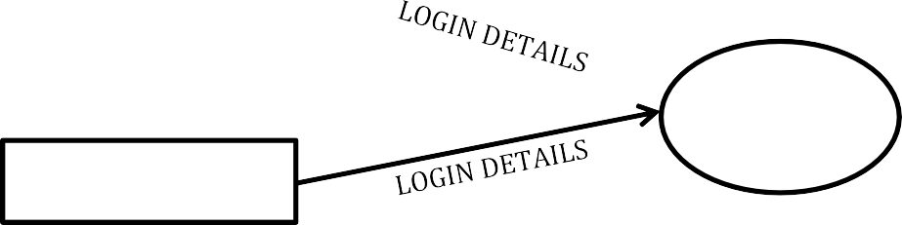

Customer

login

Admin

Order details

#### Level 1.0:

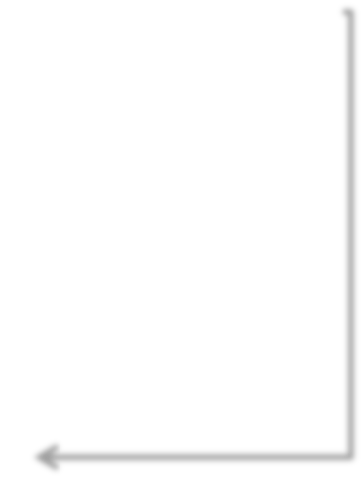

LOGIN

Customer

Login/Register

Order Bookings

Booking Details

**DB**

Payment

VIEW RECEIPT

Invoices/ receipt

**Level 1.1:**



Customer

login

Login

VIEW RECEIPT

Print Recipt

**Level 2:**



Admin

login

Login

Stock Updates

Sales Report

Product Availability

Product details

**DB**

Product availability

sales details

## DATABASE DESIGN

Table 1.1 Customer _details

|  |  |  |  |
| --- | --- | --- | --- |
| **Field Name** | **Data type** | **Size** | **Constraints** |
| Customer-name | char | 30 | Not null |
| Customer-no | integer | 10 | Primary key |
| Shop-name | char | 45 | Not null |
| Address | Varchar | 50 | Not null |

Table 1.2 Product_ details

|  |  |  |  |
| --- | --- | --- | --- |
| **Field Name** | **Data Type** | **Size** | **Constrains** |
| Fruits | char | 25 | Not null |
| Variety | varchar | 30 | Not null |
| Quantity | integer | 15 | Not null |

Table 1.3 Pre-Booking

|  |  |  |  |
| --- | --- | --- | --- |
| **Field Name** | **Data Type** | **Size** | **Constrains** |
| Name | Char | 30 | Not null |
| Address | Varchar | 50 | Not null |
| Phone number | integer | 10 | Primary key |
| Due date | date | - | Not null |

Table 2.1 Employee _details

|  |  |  |  |
| --- | --- | --- | --- |
| **Field Name** | **Data type** | **Size** | **Constrains** |
| Name | Char | 20 | Not null |
| Id | Integer | 10 | Primary key |
| Phone number | Integer | 10 | Not null |
| Address | Varchar | 40 | Not null |

Table 2.2 Sales _Report

|  |  |  |  |
| --- | --- | --- | --- |
| **Field Name** | **Data type** | **Size** | **Constrains** |
| Fruits | Char | 30 | Not null |
| Total_ Purchase | Integer | 20 | Not null |
| Total_ Sales | Integer | 20 | Not null |
| Stock | Integer | 20 | Not null |

Table 2.3 Stock _details

|  |  |  |  |
| --- | --- | --- | --- |
| **Field Name** | **Data type** | **Size** | **Constrains** |
| Fruits | Char | 20 | Not null |
| Variety | Varchar | 25 | Not null |
| Quantity | Integer | 30 | Not null |
| Date | Date | - | Not null |

Table 2.4 Salary _details

|  |  |  |  |
| --- | --- | --- | --- |
| **Field Name** | **Data type** | **Size** | **Constrains** |
| Name | Char | 20 | Not null |
| Id | Integer | 10 | Primary key |
| Phone number | Integer | 10 | Not null |
| Experience | Integer | 15 | Not null |
| Amount | Integer | 20 | Not null |

**Testing process:**

# SYSTEM TESTING

Software testing is a crucial element of software quality assurance and represents the acclimate review of the specification, design and coding. The user tests the developed system and changes are made according their needs. The testing phase involves all the testing for developed system using various kinds of data.

System testing is the stage of implementation that is aimed at assuring that the system works accurately and efficiently before live operation commences. Testing is the vital to the success of the system. System testing makes a logical assumption that if all parts of the system are correct, the goal will be successfully achieved.

Testing strategies

* + Unit testing
  + Integration testing
  + Validation testing

## Unit Testing:

Unit testing so cases verification effort on the smallest unit of software design of the model. This is also known as module testing. The modules of the system are tested separately. This testing was carried out during programming stage itself. Validation to each of the text boxes, buttons include in this type of testing.

For example, we have tested whether the text box accepts only numbers or not. We checked whether the home button is works properly goes to first page or not. Etc.,

## Integration Testing:

Data can be lost across an interface, the module can have an adverse effect on another, and sub functions when combined may not produce the desire major function.

Integration testing is the systematic technique for constructing the program structure, while at the same time conducting test to uncover errors associated within the interface. Proper Integration includes correct working when several modules work as a whole the changes in module should get reflected in the other and should not lead to any sort of error when the different modules work as whole.

## Validation Testing:

At the culmination of integration testing software is completely assume as a package. Interfacing errors have been uncovered and corrected and final series of software test i.e., validation test begins. Validation testing can be defined in many ways, but a simple definition is that validation succeeds when the software functioned in a manner that can be reasonably expected by the customer.

We checked whether the whole system is works correctly or not by combining all modules in the system.

For example,

* + - We checked whether it moves to first, next or a particular page correctly or not.
    - We tested whether data are correctly stored into corresponding tables or not Etc.,

# SYSTEM IMPLEMENTATION

Implementation is the process of converting developed system into an Operational one. The implementation is one of the most important phases of the systems development. There are three types of implementation.

* Implementation of a computer system to replace a manual system.
* Implementation of a new computer system to replace an existing one.
* Implementation of a modified application to replace an existing one

This system falls under first category. The system has been successfully implemented with Php and MS SQL SERVER as its database. After considering all the phases of the system life cycle, the developed system is now implemented with the features of user friendliness, security. Attractive form designs and well-defined functionalities. The system has been implemented to the satisfaction of the users and learners, by means of analyzing user requirements.

# CONCLUSION

Our project has the features of ordering through online by seeing the availability

Thus, this website makes your orders easily and save your time of purchasing fruits. Our pre-booking makes you all more comfortable and relax your future needs.

## FUTURE ENHANCEMENT

* + - In future I could and the Invoice of the purchased and payment must send to customer mail-id (or) phone number.
    - In Future I could and the employee details belongs to my company
    - Product availability shown to customer.
    - Sales report generation.

# REFERENCE

### Web-site:

* + - https://[www.geeksforgeeks.org/](http://www.geeksforgeeks.org/)

### https://[www.w3schools.com/](http://www.w3schools.com/)

* + - https://[www.tutorialspoint.com/](http://www.tutorialspoint.com/)

### https://youtu.be//h77m14du900

* + - https:// youtu.be//d88qe051ux0

**10.1 SCREEN SHOTS**

# ANNEXURE

### User Front Page:

In this front page customer can see the order page, pre-booking page ,contact us and about us .

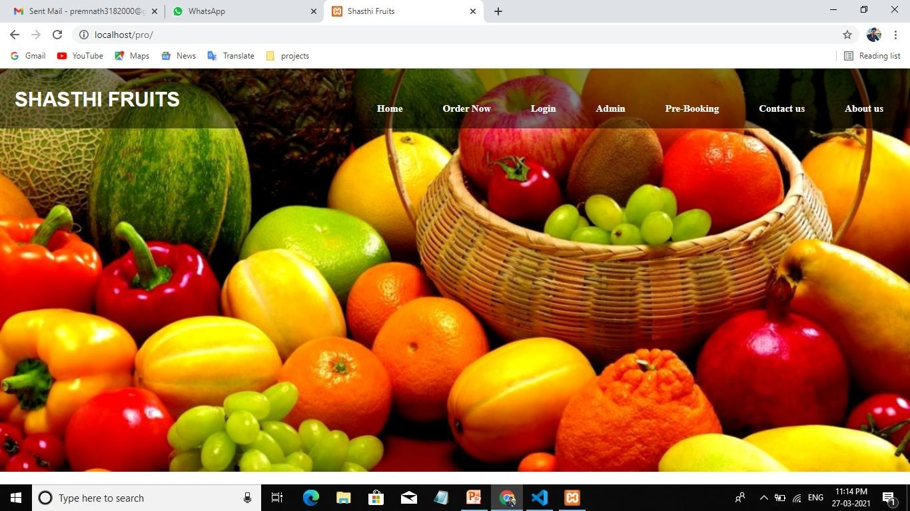

Fig :1

Order Booking Page:

In this page customer can place their orders by entering the details

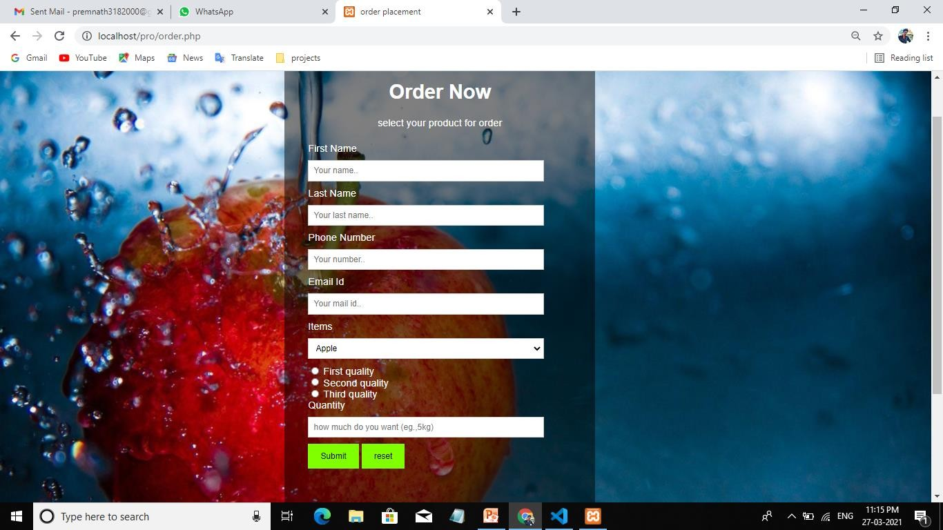

Fig : 2

### Login page:

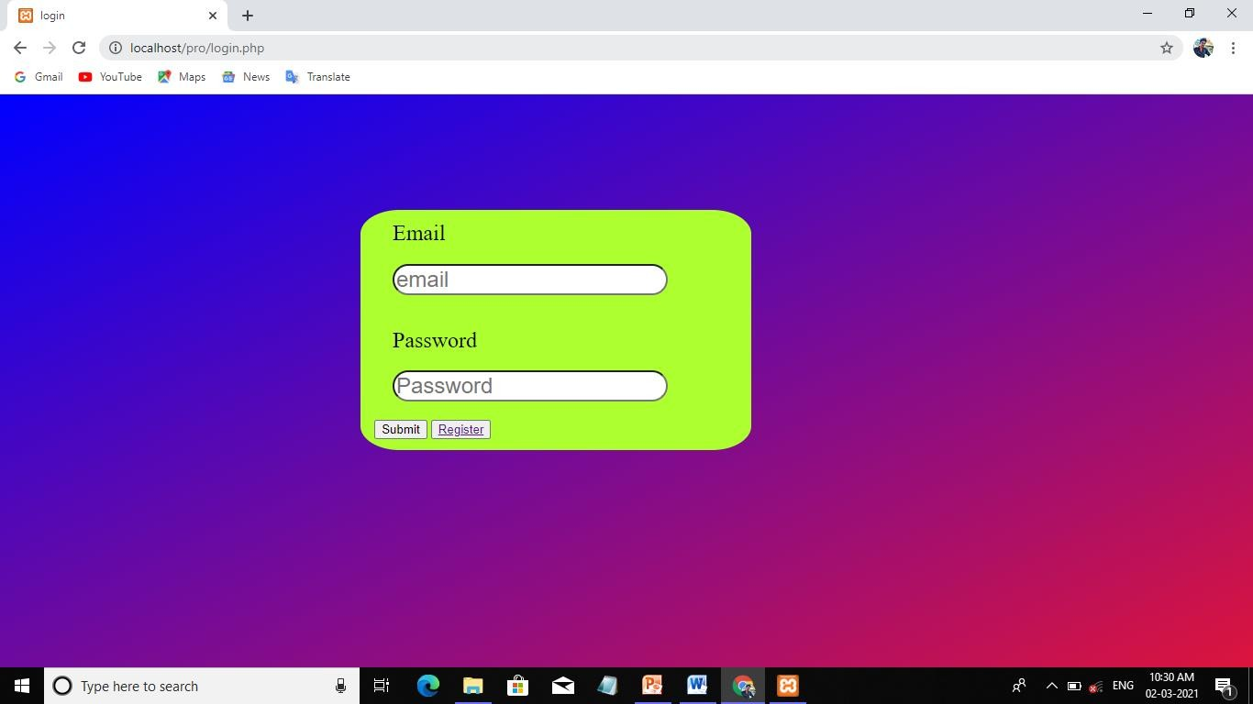

Fig:3

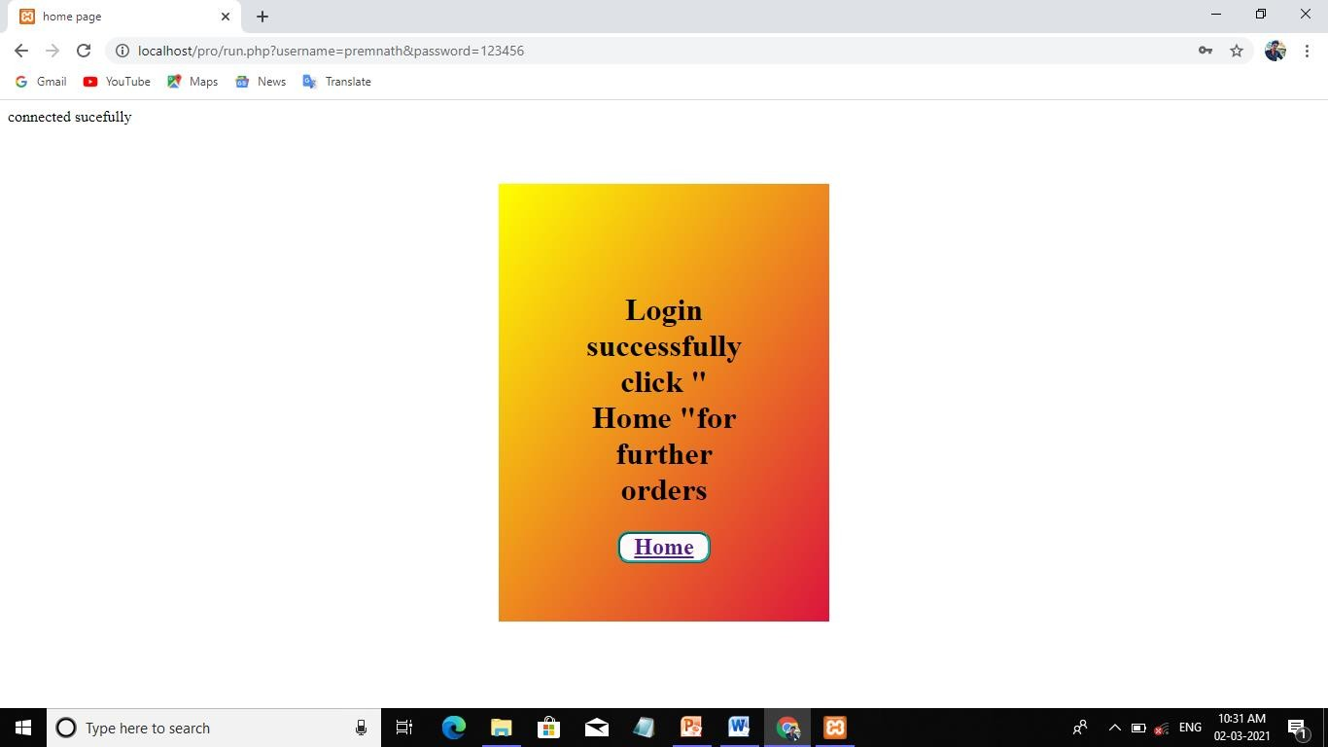

Pre-Booking page:

In the pre-Booking page customer can pre booking their orders with the specify date.

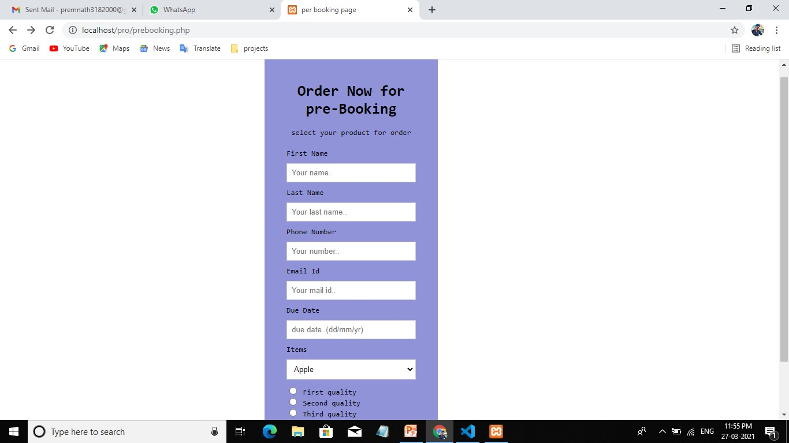

Fig: 4

### Admin Page:

In the admin page admin can updates the stock and manage the employee details regards their login.

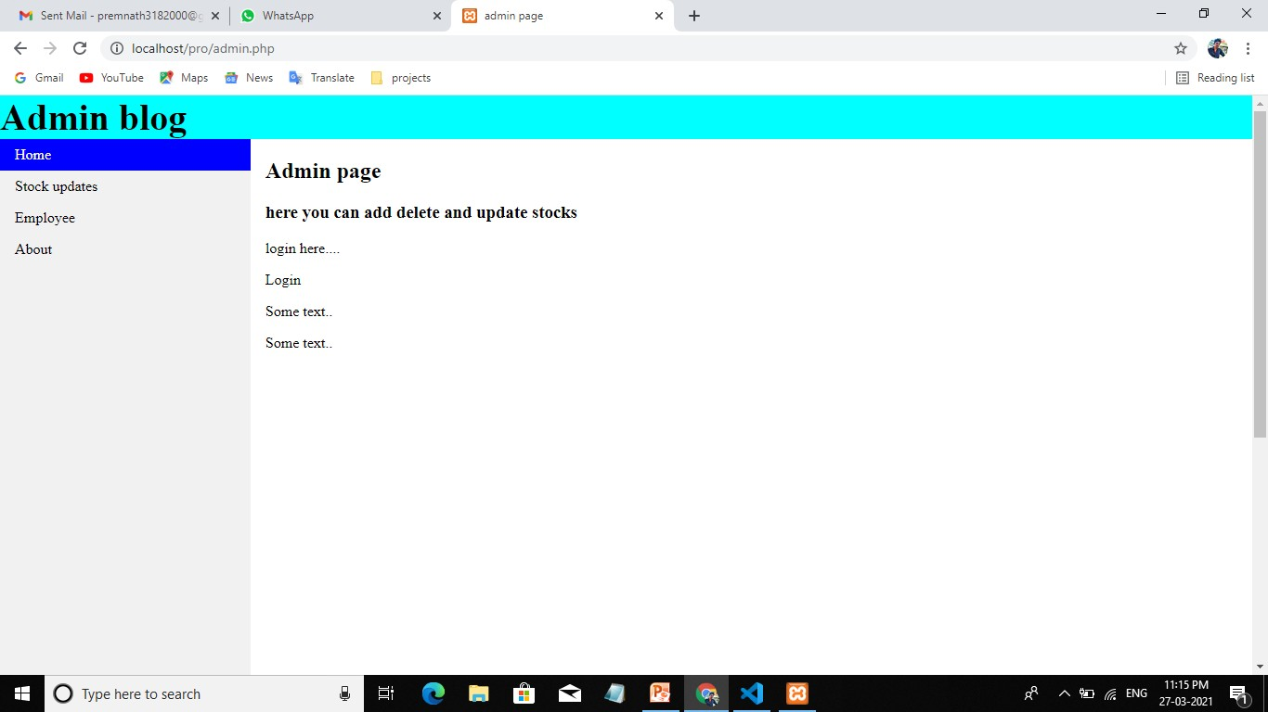

Fig: 5

### Stock Updates:

In the stock update page admin can updates the stocks and a preview is displayed near.

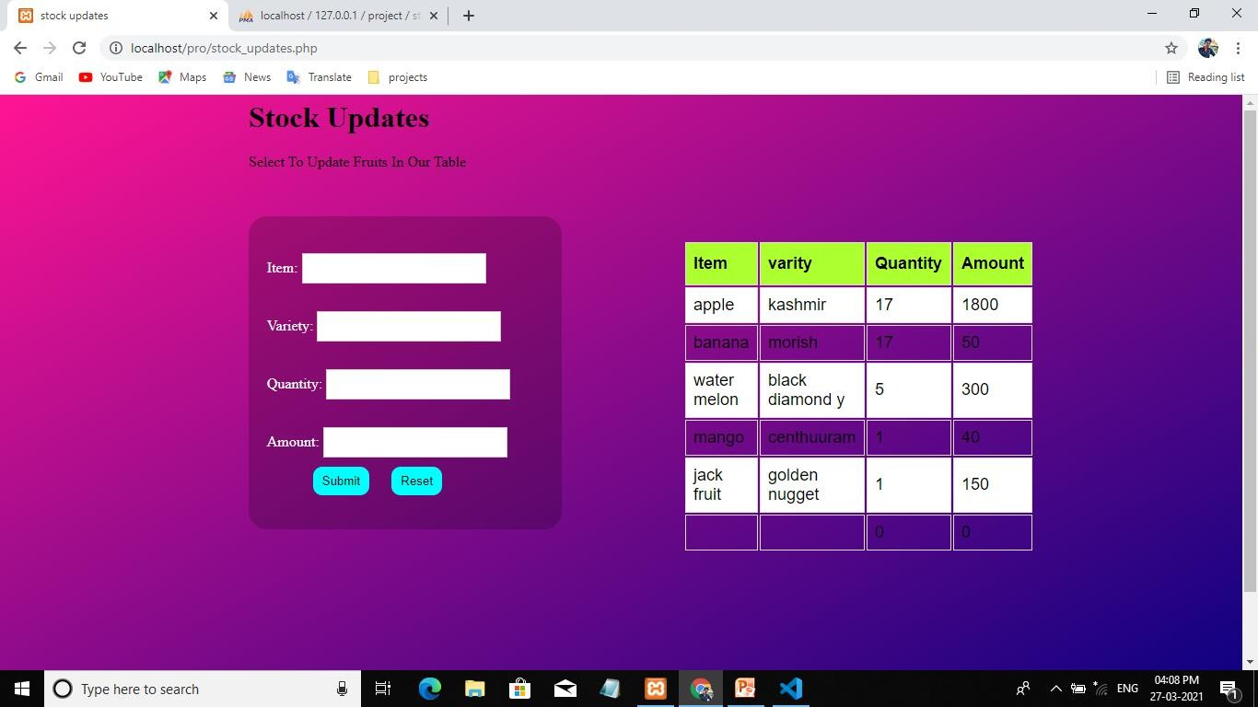

Fig: 6

### Contact us:

In the contact us page customer can make directions to our shop by using Google map service and also make calls by clicking on the contact number.

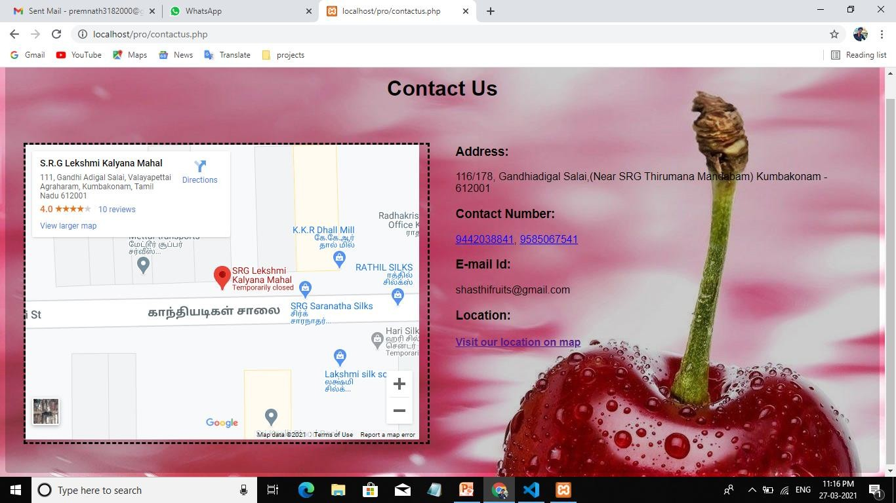

Fig:7

### About us:

In the about us page customer can easily guide by their orders and there lot of information to be displayed about our websites and products.

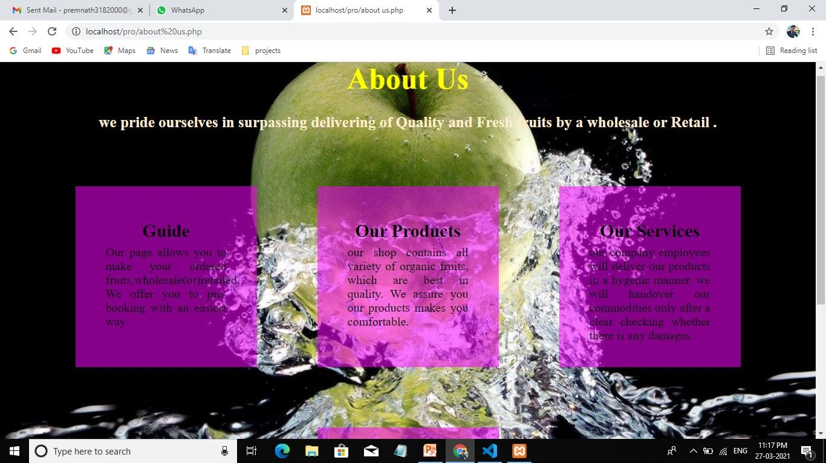

Fig: 8

# 10.2.SAMPLE CODING:

### Stock Updates:

</head>

<body>

<div style="text-align:lefttext-align:center; text-size-adjust: auto;

text-transform: capitalize">

<h1>stock updates</h1>

<p>select to update fruits in our table </p>

</div>

<form action="" class="stock_entry" method="post">

<div class='container'>

<label for="t1"> Item:</label>

<input type=text name="t1">

<br> Variety:

<input type=text name="t2">

<br> Quantity:

<input type=text name="t3">

<br> Amount:

<input type=text name="t4">

<br>

<input type=submit name="s"placeholder="add">

<input type=reset name="r">

</div>

<?php if(isset($_POST['s']))

{

$a=$_POST['t1']; //accessing value from the text field

$query=" INSERT INTO `stock_updates`( `items`, `variety`, `quantity`,`amount`) VALUES ('$_POST[t1]','$_POST[t2]','$_POST[t3]','$_POST[t4]')";

$result=mysqli_query($conn,$query); if($result)

{

echo " new item added succesfully-".$a; //displaying result

}else{

echo "connection error";

}

}

?>

</form>

<div class="list">

<table>

<tr>

<th>Item</th>

<th>varity</th>

<th>Quantity</th>

<th>Amount</th>

</tr>

<?php

$query="SELECT * FROM `stock_updates`";

$res=mysqli_query($conn,$query); while($row=mysqli_fetch_assoc($res)){

?>

<tr>

<td><?php echo $row['items']; ?></td>

<td><?php echo $row['variety']; ?></td>

<td><?php echo $row['quantity']; ?></td>

<td><?php echo $row['amount']; ?></td>

</tr>

<?php } ?>

</table>

</div>

</body>

</html>

### Order Booking:

<html>

<head>

<title>order placement </title>

<meta name="viewport" content="width=device-width, initial-scale=1">

<style> body {

font-family: Arial, Helvetica, sans-serif; background:url("apple2.jpg"); color:white;

background-size: cover;

background-position:left;

}

* {

box-sizing: border-box;

}

/* Style inputs */ input[type=text], select, textarea { width: 100%;

padding: 8px;

border: 1px solid #ccc; margin-top: 10px; margin-bottom: 10px; resize: vertical;

}

input[type=radio], { width: 100%;

padding: 8px;

border: 1px solid #ccc; margin-top: 4px; margin-bottom: 1px;

resize: vertical;

}

input[type=submit] {

background-color:chartreuse; color: black;

padding: 12px 20px; border: none; cursor: pointer;

}

input[type=submit]:hover { background-color: #45a049;

}

input[type=reset] {

background-color:chartreuse; color: black;

padding: 12px 20px; border: none; cursor: pointer;

}

input[type=reset]:hover { background-color: #45a049;

}

.container {

border-radius: 10px; background:rgba(0,0,0,0.5); background-size:900px; margin-left:450;

width:500; margin-top:50;

margin-bottom:200; height:770; padding: 30px;

}

.column { float: center; width: 90%;

margin-top:2px; padding: 8px;

}

/* Clear floats after the columns */

.row:after { content: ""; display: table; clear: both;

}

/* Responsive layout - when the screen is less than 600px wide, make the two columns stack on top of each other instead of next to each other */

@media screen and (max-width: 600px) {

.column, input[type=submit] { width: 100%;

margin-top: 0;

}

.column, input[type=reset] { width: 100;

margin-left:10; margin-right:0; margin-top: 2;

}

}

</style>

</head>

<body>

<div class="container">

<div style="text-align:center">

<h1>Order Now</h1>

<p>select your product for order </p>

</div>

<div class="row">

<div class="column">

<form action="/action_page.php"method="post">

<label for="fname">First Name</label>

<input type="text" id="fname" name="firstname" placeholder="Your name..">

<label for="lname">Last Name</label>

<input type="text" id="lname" name="lastname" placeholder="Your last name..">

<label for="phno">Phone Number</label>

<input type="text" id="phno" name="phonenumber" placeholder="Your number..">

<label for="email">Email Id</label>

<input type="text" id="email" name="email" placeholder="Your mail id..">

<label for="Items">Items</label>

<select id="Items" name="Items">

<option value="apple">Apple</option>

<option value="banana">Banana</option>

<option value="orange">Orange</option>

<option value="papaya">Papaya</option>

<option value="pineapple">Pine apple</option>

</select>

<input type="radio" id="a1" name="quality" value="a1">

<label for="a1">First quality</label><br>

<input type="radio" id="a2" name="quality" value="a2">

<label for="a2">Second quality</label><br>

<input type="radio" id="a3" name="quality" value="a3">

<label for="a3">Third quality</label><br>

<label for="quantity">Quantity</label><br>

<input type="text" id="quantity" name="quantity" placeholder="how much do you want (eg.,5kg)">

<input type="submit" value="Submit">

<input type="reset" value="reset">

</div>

</div>

<h1></h1>

</body></head></html>

<?php

$fname=($_POST['fname']);

$lname=($_POST['lname']);

$phno=($_POST['phno']);

$email=($_POST['email']);

$duedate=($_POST['duedate']);

$apple=($_POST['apple']);

$banana=($_POST['banana']);

$orange=($_POST['orange']);

$papaya=($_POST['papaya']);

$pineapple=($_POST['pineapple']);

if(isset($_POST["submit"]))

{

$conn=mysqli_connect("localhost","root","","order_details"); if(!$conn)

{

echo"Database is not connected";

}

$query="INSERT INTO `order_details`(`order_id`, `first_name`, `last_name`,

`phone_number`, `email_id`, `due_date`, `items`, `quality`, `quantity`) VALUES ([fname],[lname],[phno],[email],[duedate],[item],[quality],[quantity])";

if(mysqli_query($conn,$query))

{

echo"NEW RECORD CREATED SUCCESSFULLY ";

}

else

{

echo"Error:".$query."</br>".$conn->error;

}

}

?>

</html>

</form>

</body></html>

### Index page:

<body>

<h2></h2>

<p></p>

<div class="container">

<div style="text-align:center">

<h1>Contact Us</h1>

</div>

<div class="row">

<div class="column">

<p class="dashed"><iframe src="https:/[/www.google.co](http://www.google.com/maps/embed?pb=!1m18!1m)m[/maps/embed?pb=!1m18!1m](http://www.google.com/maps/embed?pb=!1m18!1m) 12!1m3!1d291.1393357170685!2d79.37493664928809!3d10.956696386872933!2m3!1f

0!2f0!3f0!3m2!1i1024!2i768!4f13.1!3m3!1m2!1s0x3baacd4bdfa585f3%3A0xae2ac2ef0 372b07a!2sS.R.G%20Lekshmi%20Kalyana%20Mahal!5e0!3m2!1sen!2sin!4v161665887 7163!5m2!1sen!2sin" width="600" height="450" style="border:0;" allowfullscreen="" lo ading="lazy"></iframe></p>

</div>

<div class="column">

<form action="/action_page.php">

<h3>Address:</h3>

<p> 116/178, Gandhiadigal Salai,(Near SRG Thirumana Mandabam) Kumbakonam

- 612001</p>

<h3>Contact Number:</h3>

<p><a href="tel:9442038841"title="click to call">9442038841</a>,

<a href="tel:9585067541"title="click to call">9585067541</a></p>

<h3>E-mail Id:</h3>

[<p>dailyfreshfruits@gmail.co](mailto:shasthifruits@gmail.com)m</p>

<h3>Location:</h3>

<h4> <p><a href="https://goo.gl/maps/aUS7q7Ph79Tp596y7" title="Go to map for d irections">Visit our location on map</a>

</h4> </p>

</form>

</div>

</div>

</div>

</body>